Introduction
A soda can is a good model of a thin walled pressure vessel. The stresses a cylindrical pressure vessel experience due pressure are hoop stress and axial stress, which are represented in the figure below.
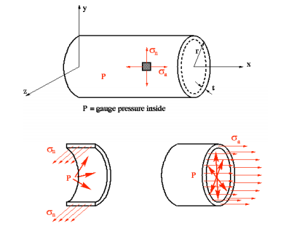Figure 1: Forces in a thin walled pressure vessel
Hoop stress is a normal stress to the circumference. Axial stress is parallel to the axis of symmetry.
In this experiment, the strain gauge will be measuring hoop strain. In order go get the stress the following equation must be used.

With the hoop stress the pressure in the vessel can be found using the following equation.

Where P is the vessel pressure, t is the wall thickness, r is the inner radius of the vessel, and sigma is the hoop stress. The axial stress can be found using the following equation.

